**Course: Object Oriented Programming**

**Lab 04**

**Composition**

**Task 1**:

Make a class **Address** that have three attributes, streetNumber, city and country. All attributes are private and will be exposed using getter and setter method.

Make an **Employee** class, which have employeeID, employeeName and emplyeeAddress. All attributes are private. Attributes employeeAddress should be of type Address. In this class, define a constructor, which takes two parameters i.e. employeeID and emplyeeAddress.

Make another class **EmployeeTest**, in main method, instantiate an employee object named employee1. Initialize id and address attribute using constructor. The attribute name should be initialized using setter method. User should give value of name attribute. Also, print values of all attributes using getter.

Make another employee object named employee2. Both employees share same address. Print the id and address for employee2.

**Expected Output:**

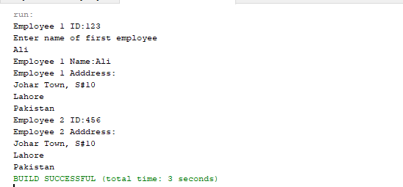

**Task 2**:

Make a class **Date** with three attributes, day, month and year. All attribute are private. In constructor, you have to validate day. If day is out of range, you have to print a message, “Invalid Date”. Suppose all months have 30 days.

Make a class **Employee** that has four instance variable firstName, lastName, birthdate and hiringDate. firstNmae and lastName are reference to String object while birthdate and hiringDate are references to Date object. All instance variable are private. Employee class has a fully parameterized constructor.

Make another class **EmployeeTest**. In main method, instantiate two Date object to represent birthdate and hiringDate of employee. Now instantiate one object for Employee named employee1 and initialize firstName and lastName using constructor. Print values of all attributes using getter method.

**Expected Output:**

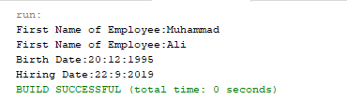

**Task 3:**

For each class/attributes described below, choose appropriate data type. All attributes of each class should be private and exposed via get/set methods. Also define at least one constructor shall take and initialize 2-3 attributes of the object.

1. Define a class **Course** with courseCode and courseTitle attributes.
2. Define a class **PhoneNumbe**r with countryCode, cityCode and lineNumber attributes.
3. Define a class **Address** with streetAddress, town, city, country and phoneNumber attributes. Attribute phoneNumber shall be of type PhoneNumber.

Define a class **Student** with name, email, cnic, course1, course2, postalAddress and contactNumber attributes. Where course1 and course2 should be of type Course, postalAddress shall be of type Address; contactNumber should be of Type PhoneNumber. Define a constructor in Student class that takes cnic, name and address only.

Create a **StudentTest** class, in its main method, create a Student object i.e. student1. Fully initialize its’ all attributes. cnic, name and address shall be initialized by constructor, other attributes shall be initialized using setter methods. **All attributes values shall be taken from user.** After the object is fully initialized, print all, attribute values from student object reference.

Make another object student2, assume the student live at same address as student1. Reuse the address object of student1 to initialize student2 address. You do not need to take attributes from user input for

student2 object. Change some attribute of address from student1 and check, does it also change for student2, understand why and why not?